SWITCHVI 96 Summary 1 November 2005

Ellipse experiment studying the effect of switching of assignment keys according to the color of ellipse. We have 96 subs in 8 groups, 12 per group.
We use 2 category structures: CJ & II.
4 conditions: 2catControl, 2catSwitch, 4catColor & 4catControl.
Description of conditions:
2catControl regular 2 cat CJ or II, color of ellipse varies, but irrelevant
2catSwich 2 cat CJ or II, but if black ellipses are short=A & long=B, then white ellipses have opposite assignment
4catColor 2 cat per one ellipse color; white ellipses are A or B, black ellipses are C or D; similar to 2catSwitch, except that different color ellipses have different response keys
4catControl regular 4 cat CJ (+) or II (X), color of ellipse varies but irrelevant

Accuracy analyses
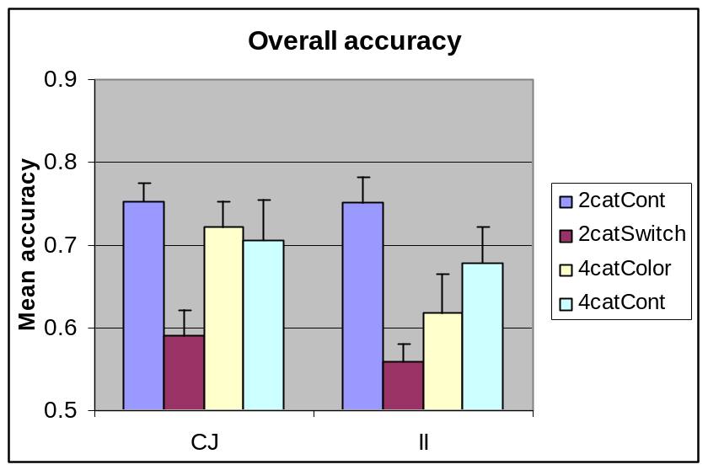

Nice thing is that we have control condition performance equated over CJ and II.

There are significant differences among groups, driven primarily by low 2catSwitch performance.
3-way ANOVA (5 block x 2 catStr x 4 condition) shows only main of block, main of condition, block*condition interaction.

I also took only pairs of conditions that looked promising/are interesting as experiment per se and run 3-way ANOVAs on them (5 block x 2 catStr x 2 selected conditions):
2catSwitch x 4catColor:
Main of block, main of condition, main of catStr, block*condition interaction.
4catColor x 4catControl
Main of block, block*condition interaction only.
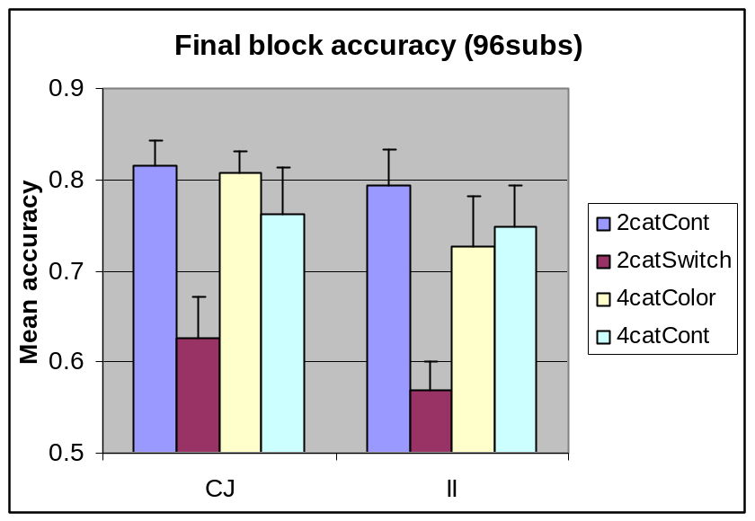

A look at the final block accuracies suggested that while CJ & II are equated on control performance (i.e. when color is irrelevant), CJ seems to do a bit better on than II on the color-relevant conditions. I tested that with ANOVA (5 block x 2 catStr x 2 color relevance).
Unfortunately, that does not explain the results either:
Main of block, main of color relevance, block*catStr interaction.
The possibly interesting catStr*colorRelevance interaction has F=0.9, p=.3.
Pair-wise t-tests show no CJ vs II difference in color irrelevant conditions and marginal difference in color relevant condition (p=.078 in overall accuracy, Block 3 p=.064, Block 4 p=.046). There are only 12 subs per group, so if this difference is real, it can become significant with more subs in. The biggest CjxII differences are on 4catColor condition.
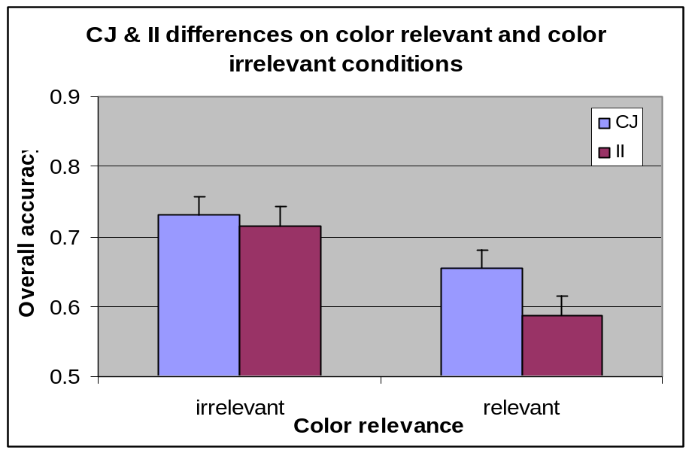

Summary, thoughts and what next
Data pattern very similar to what we saw with fewer subs.
- Switching key assignment depending on color severely impairs both CJ & II learning (2catCont vs 2catSwitch).
- The only difference between CJ & II learning is in 4catColor condition, that is almost as good as 2 catCont condition in CJ, but somewhat worse in II. This may be because color is not well represented in caudate (color relevance aproach) and/or because good performance requires only verbal system in CJ while both systems in II.

What now?
  - We may need to collect some more data to clean the data pattern. I suggest at least 4 more per group (to have 16 per group) before coming with follow-ups.
  - We should find a nice follow-up that would test the combining hypothesis and color relevance hypothesis (that may complement to create our results).
  - One such follow-up could be + and X cat structure with 2 categories only (DJ-like). It’s like switching the keys, except that the key switch dimension is continuous.
  - Another follow-up could have identical structure as our 4catColor, but use different dimension than color, something what is likely to be represented in caudate and may be incorporated into decision in II fashion.

These are all free first thoughts and may not be too useful…

At the reminder of the page, block accuracies for each structure:

